Abhishek Ojha

Seat No 027

pRACTICAL NO 6

Spatial Database

**Practical 6:**

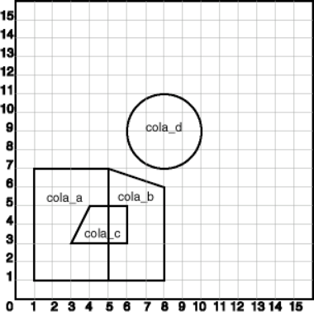**Aim:** Create a table that stores spatial data and issue queries on it.

**Software Requirement:** Oracle 11g.

**Query:**

Create a spatial database table that stores the number, name and location, which consists of four different areas say abc, pqr, mno and xyz.

Fire the following queries:

a) Find the topological intersection of two geometries.

b) Find whether two geometric figures are equivalent to each other.

c) Find the areas of all different locations.

d) Find the area of only one location.

e) Find the distance between two geometries.

**Practical Implementation:**

1. **Create a table for cola (soft drink) markets in a given geography (such as city or state). Each row will be an area of interest for a specific cola (for example, where the cola is most preferred by residents, where the manufacturer believes the cola has growth potential, and so on). (For restrictions on spatial table and column names, see .**

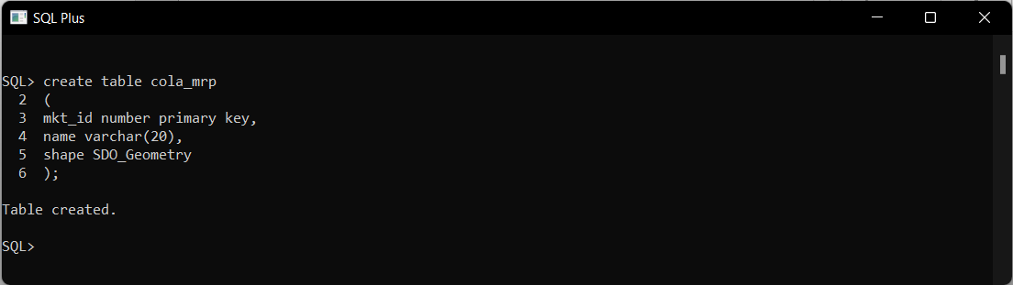

1. **The next INSERT statement creates an area of interest for Cola A. This area happens to be a rectangle. The area could represent any user-defined criterion: for example, where Cola A is the preferred drink, where Cola A is under competitive pressure, where Cola A has strong growth potential, and so on.**

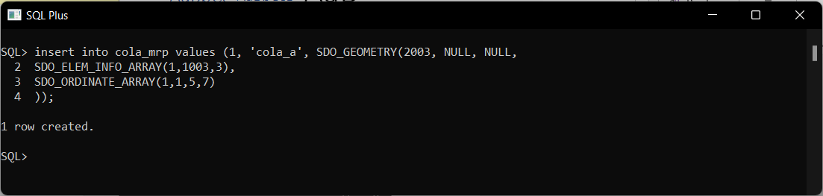

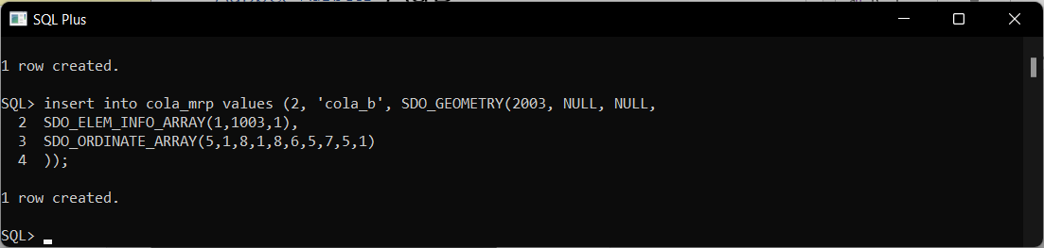

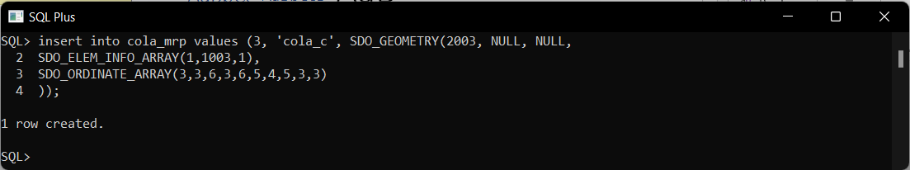

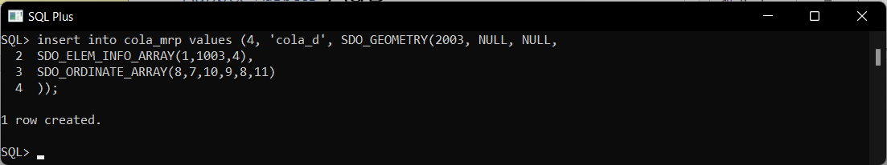

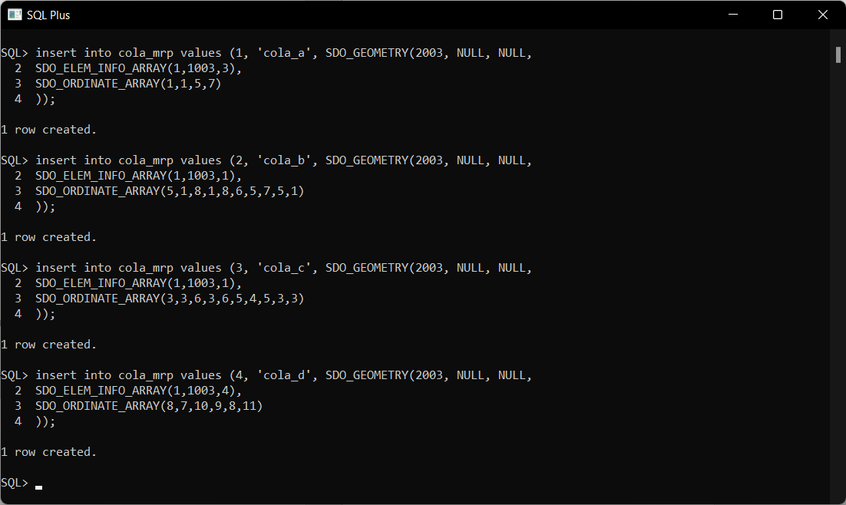

1. **UPDATE METADATA VIEW**

**Update the USER_SDO_GEOM_METADATA view. This is required before the spatial index can be created. Do this only once for each layer (that is, table-column combination; here: COLA_MARKETS and SHAPE).**

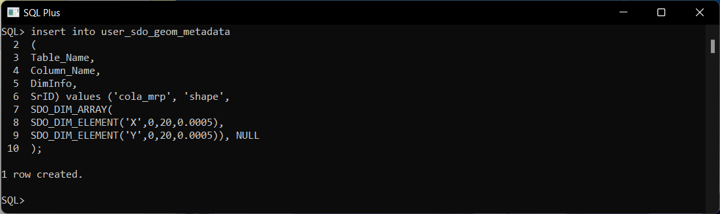

1. **CREATE THE SPATIAL INDEX.**

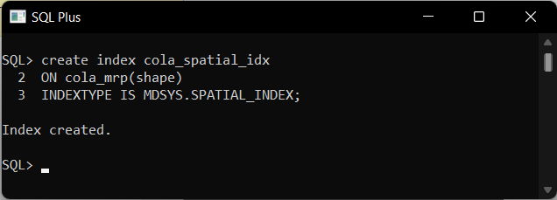

1. **PERFORM SOME SPATIAL QUERIES**

**Return the topological intersection of two geometries.**

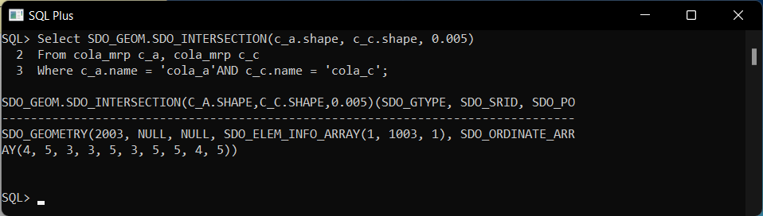

**Do two geometries have any spatial relationship?.**

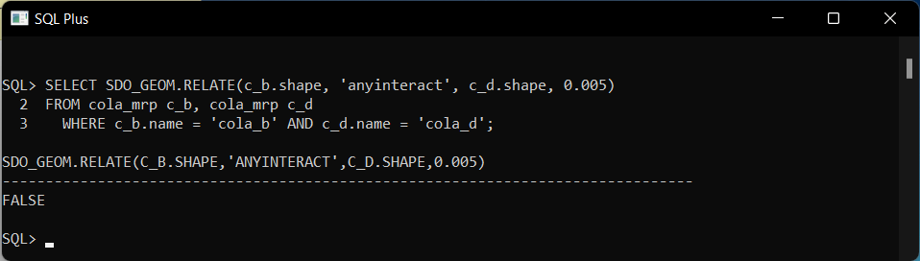

**Return the areas of all cola markets.**

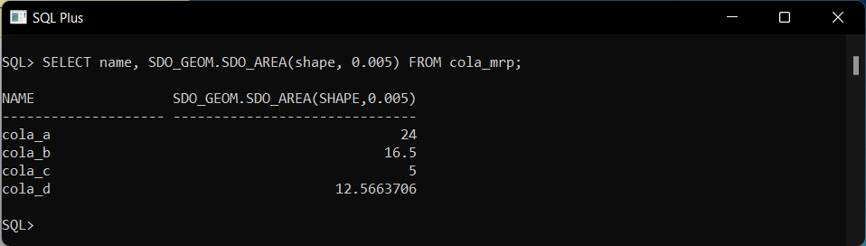

**Return the area of just cola_a.**

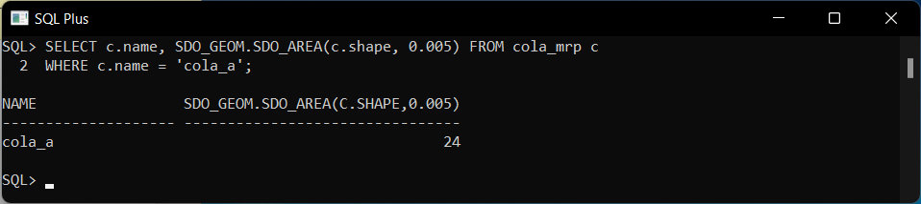

**Return the distance between two geometries.**

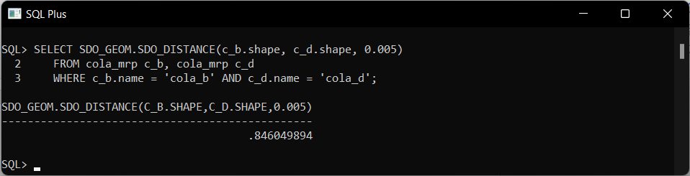

**Is a geometry valid?**

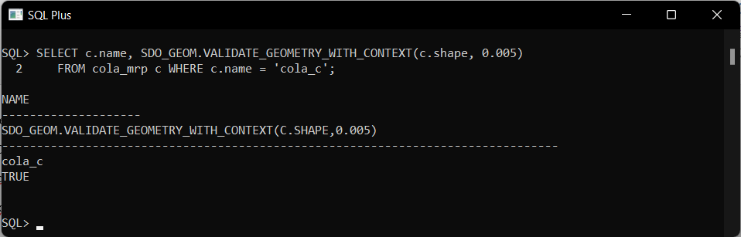

**is a layer valid? (First, create the results table).**

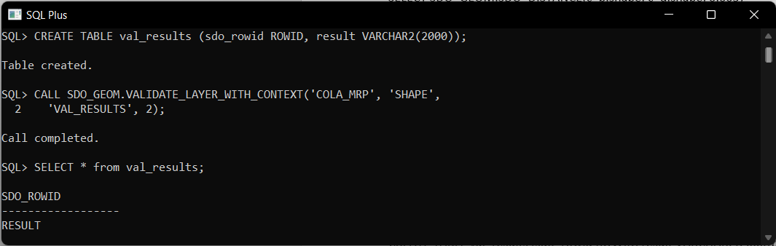

**Conclusion :** Successfully Performed the Spatial Data Queries on Oracle Database.